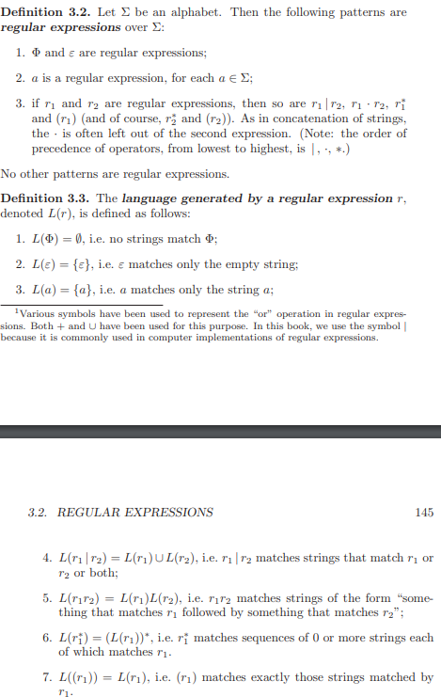



Example:

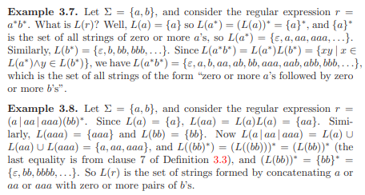

L = {x|x ends with 1} (0|1)\*1

L = {x | x starts and ends with 1} 1(0|1)\*1

L = {x | x only contains 0 or 1} 0\*|1\*